[Railway Reservation Management]

PROJECT Report

***Submitted by***

# A.Venkata DineshReddy(RA1911028010098

# CH.VamshiKrishna(RA1911028010098

# K.Spurgeon(RA1911028010109

***in partial fulfillment for the award of the degree of***

# B.TECH

***in***

COMPUTER SCIENCE and ENGINEERING

IN

CLOUD COMPUTING

# SRM INSTITUTE OF SCIENCE AND TECHNOLOGY

KATTANKULATHUR

[April, 2022]

ABSTRACT

The Railway Reservation System facilitates the passengers to enquire about the trains available on the basis of source and destination, Booking and Cancellation of tickets, enquire about the status of the booked ticket, etc. The aim of case study is to design and develop a database maintaining the records of different trains, train status, and passengers.

This project contains Introduction the Railways reservation system in .It is the computerized system of reserving the seats of train seats in advance. It is mainly used for long routes. On-line reservation has made the process for the reservation of seats very much easier than ever before.

In our country India, there are number of counters for the reservation of the seats and one can easily make reservations and get tickets. Then this project contains entity relationship model diagram based on railway reservation system and introduction relation model.There is also design of the database of the railway reservation system based on relation model.

TABLE OF CONTENT

|  |  |  |
| --- | --- | --- |
| **CHAPTER NO** | **TITLE** | **PAGE NO** |
| **1** | **ABSTRACT** | 2 |
| **2** | **INTRODUCTION** | 4 |
| **3** | **LIST OF RealationShips** | 4 |
| **4** | **Entity Relationship Diagram** | 5 |
| **5** | **Normalized Database Table** | 6 |
| **6** | **SQL Queries with results** | 12 |
| **7** | **Conclusion and Future Work** | 13 |
| **8** | **References** | 13 |

**INTRODUCTION:-**

Database is an organized collection of data. The data is typically organized to model aspects of reality in a way that supports processes requiring information. A DBMS makes it possible for end users to create, read, update and delete data in a database. The DBMS essentially serves as an interface between the database and end users or application programs, ensuring that data is consistently organized and remains easily accessible. The DBMS manages three important things: the data, the database engine that allows data to be accessed, locked and modified and the database schema, which defines the database's logical structure. These three foundational elements help provide concurrency, security, data integrity and uniform administration procedures. The DBMS can offer both logical and physical data independence. That means it can protect users and applications from needing to know where data is stored or having to be concerned about changes to the physical structure of data.

The main purpose of maintaining database for Railway Reservation System is to reduce the manual errors involved in the booking and cancelling of tickets and make it convenient for the customers and providers to maintain the data about their customers and also about the seats available at them.Due to automation many loopholes that exist in the manual maintenance of the records can be removed. The speed of obtaining and processing the data will be fast. For future expansion the proposed system can be web enabled so that clients can make vai ious enquiries about trains between stations. Due to this, sometimes a lot of problems occur and they are facing many disputes with customers. To solve the above problem, we design a data base which includes customer details, availability of seats in trains, no.of trains and their details.

LIST OF RELATION SHIPS:

1)books -Ternary relation ship between USER, TRAIN,PASSENGER and TICKET.

2)starts -Between TRAIN and STATION

3)reaches -Between TRAIN and STATION

4)cancel- Between USER and TICKET

5)stops at- Between TRAIN and STATION

**Entity Relationship Diagram:-**

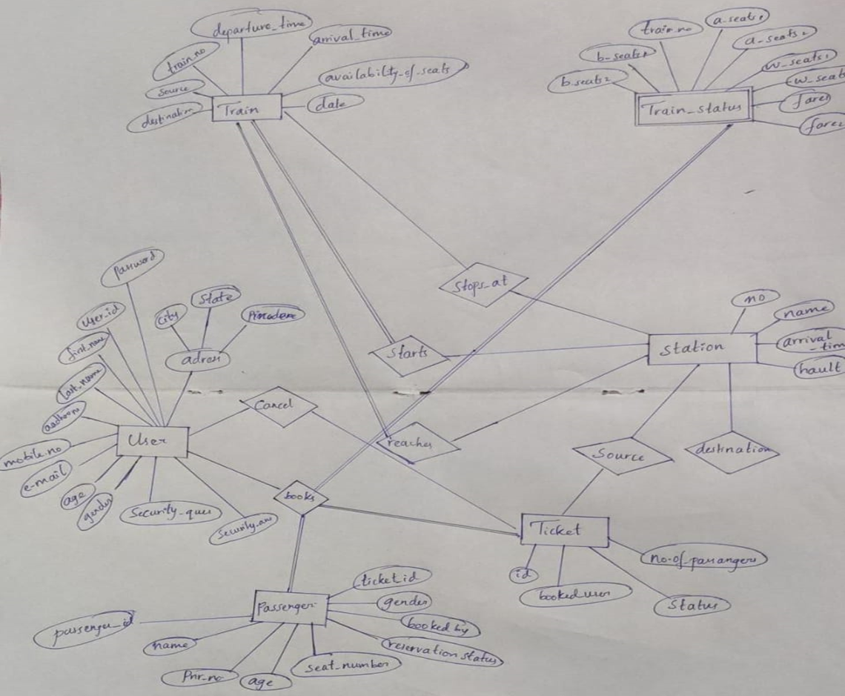

Normalized Database Table:-

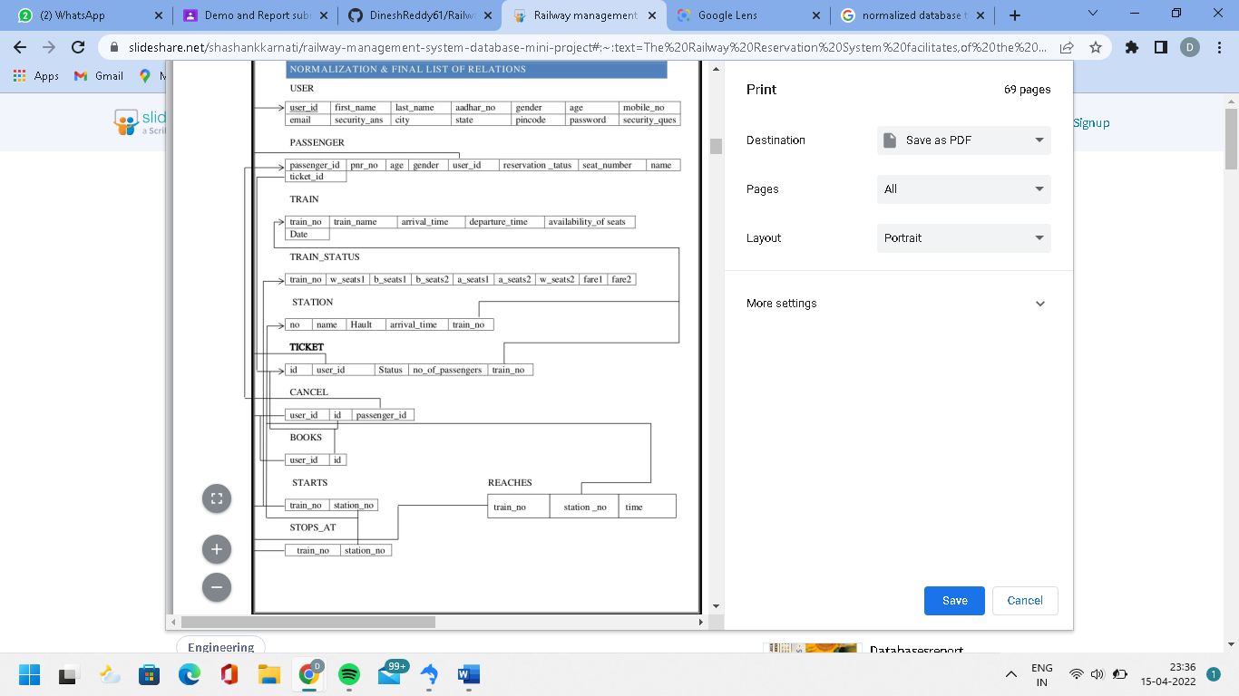

**SQL Queries:-**

CREATE TABLE IF NOT EXISTS USER (user_id INT PRIMARY KEY,first_name VARCHAR(50),last_name

VARCHAR(50),adhar_no VARCHAR(20),gender CHAR (1),age INT,mobile_no VARCHAR(50),email VARCHAR(50),city

VARCHAR(50),state VARCHAR(50),pincode VARCHAR(20),_password VARCHAR(50),security_ques

VARCHAR(50),security_ans VARCHAR(50));

CREATE TABLE IF NOT EXISTS TRAIN(train_no INT PRIMARY KEY,train_name VARCHAR(50),arrival_time

TIME,departure_time TIME,availability_of_seats CHAR,datee DATE);

CREATE TABLE IF NOT EXISTS STATION(station_no INT, namee VARCHAR(50),hault INT,arrival_time TIME,train_no INT,PRIMARY KEY(station_no,train_no), CONSTRAINT FOREIGN KEY(train_no) REFERENCES

TRAIN(train_no));

CREATE TABLE IF NOT EXISTS TRAlN_STATUS(train_no INT PRIMARY KEY,b_seats1 INT,b_seats2

INT,a_seats1 INT,a_seats2 INT,w_seats1 INT,w_seats2 INT,fare1 FLOAT,fare2 FLOAT);

CREATE TABLE IF NOT EXISTS TICKET(id INT PRIMARY KEY,user_id INT,statuss CHAR,no_of_passengers

INT ,train_no INT,CONSTRAINT FOREIGN KEY(user_id) REFERENCES USER (user_id),CONSTRAINT FOREIGN

KEY(train_no) REFERENCES TRAIN(train_no));

`train`

CREATE TABLE IF NOT EXISTS PASSENGER(passenger_id INT PRIMARY KEY,pnr_no INT,age INT,gender

CHAR,user_id INT,reservation_status CHAR,seat_number VARCHAR(5),namee VARCHAR(50),ticket_id

INT,CONSTRAINT (fk_userid) FOREIGN KEY(user_id) REFERENCES USER user_id,CONSTRAINT FOREIGN KEY(ticket_id)

REFERENCES TICKET(id));

CREATE TABLE IF NOT EXISTS START( train_no INT PRIMARY KEY,station_no INT,CONSTRAINT FOREIGN

KEY(train_no) REFERENCES TRAIN(train_no),CONSTRAINT FOREIGN KEY(station_no) REFERENCES

STATION(station_no));

CREATE TABLE IF NOT EXISTS STOPS_AT( train_no INT,station_no INT,CONSTRAINT FOREIGN KEY(train_no)

REFERENCES TRAIN(train_no),CONSTRAINT FOREIGN KEY(station_no) REFERENCES STATION(station_no));

CREATE TABLE IF NOT EXISTS REACHES(train_no INT,station_no INT,timee TIME,CONSTRAINT FOREIGN

KEY(train_no) REFERENCES TRAIN(train_no),CONSTRAINT FOREIGN KEY(station_no) REFERENCES

STATION(station_no));

CREATE TABLE IF NOT EXISTS BOOKS( user_id INT,id INT,CONSTRAINT FOREIGN KEY(user_id) REFERENCES

USER (user_id),CONSTRAINT FOREIGN KEY(id) REFERENCES TICKET(id));

CREATE TABLE IF NOT EXISTS CANCEL(user_id INT,id INT,passenger_id INT,CONSTRAINT FOREIGN KEY(id)

REFERENCES TICKET(id),CONSTRAINT FOREIGN KEY(passenger_id) REFERENCES PASSENGER(passenger_id),CONSTRAINT FOREIGN KEY(user_id) REFERENCES USER (user_id));

INSERT INTO

USER VALUES (1701,'Vijay','Sharma','309887340843','M',34,'9887786655','vijayl@gmail.com','vijayawada','andhrapradesh','520001','12345@#','favouritecolour','red');

INSERT INTO

USER VALUES (1702,'Rohith','Kumar','456709871234','M',45,'9809666555','rohith1kumar@gmail.com','guntur','andhrapradesh','522004','12@#345','favouritebike','bmw');

INSERT INTO

USER VALUES (1703,'Mananasvi',’’,'765S43210987','F',20,'999555Ofifi6','mananasvi57@gmail.com','guntur','andhra pradesh','522004','O987hii','favouritef1ower','rose');

INSERT INTO TRAIN VALUES (12711,'pinakini exp','113000','114000','A',20170410);

INSERT INTO TRAIN VALUES (12315,'corimandel exp','124500','125000', 'N' ,20170410 );

INSERT INTO STATION (station_no,namee,hault,arrival_time,train_no) VALUES (111,'vijayawada',10,'11:30:00',12711);

INSERT INTO

station VALUES (222,'tirupathi',5,'1l:45:00',12315);

INSERT INTO PASSENGER (passenger_id,pnr_no,age,gender,user_id,reservation_status,

seat_number,NAME,ticket_id) VALUES ( 50O1,78965,45,'M',1701,'C' ,'B6-

45','rainesh',4001),(5OO2,54523,54,'F',1701,'W','B3-21','surekha',40O2);

INSERT INTO STARTS(train NO,station NO) VALUES(l2315,222);

INSERT INTO STOPS_AT(train NO,station NO) VALUES(12711,222),(12315,111);

INSERT INTO REACHES(train NO,station NO,TIMEe) VALUES(12711,222,'12O000'), (12315,111,'O53500');

INSERT INTO BOOKS(user_id,id) VALUES(1701,77),(1702,4002);

INSERT INTO CANCEL(USER id,id,passenger id) VALUES(17O1,4001,5OO1);

SQL Queries with results

1.Print user id and name of all those user who booked ticket for corimandel express?

SELECT u.user_id,CONCAT(u.first_name,u.last_name) AS NAME

FROM USER u,train t,ticket tc

WHERE u.user_id=tc.user_id AND t.train_no=tc.train_no AND t.train_name LIKE 'corimandel exp';

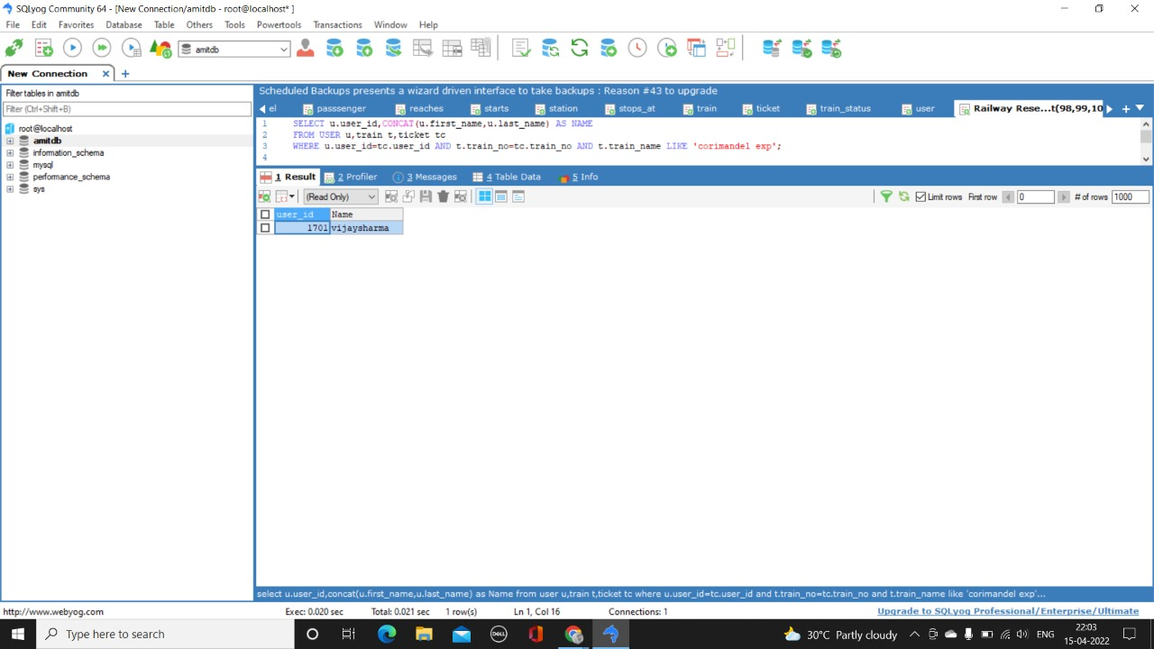

2. Print details of passengers travelling under ticket no 77?

SELECT * FROM passenger WHERE ticket_id = 77;

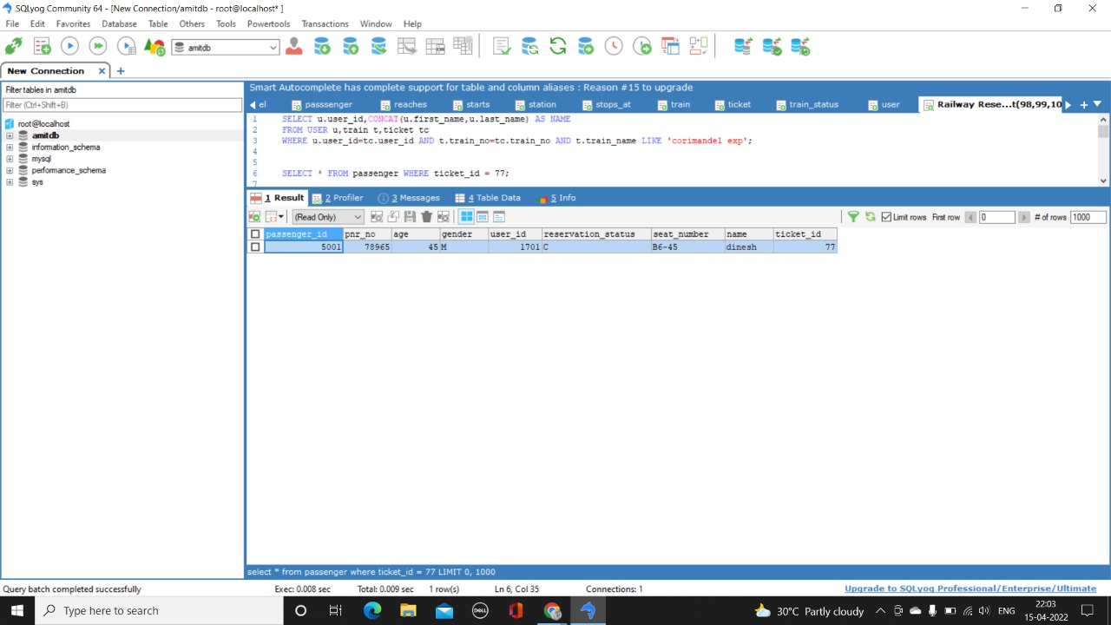

3. Display all those train no's which reach station no 111?

SELECT t.*

FROM train t,station s,reaches r

WHERE t.train_no=r.train_no AND r.station_no=s.station_no AND s.namee LIKE 'vijayawada';

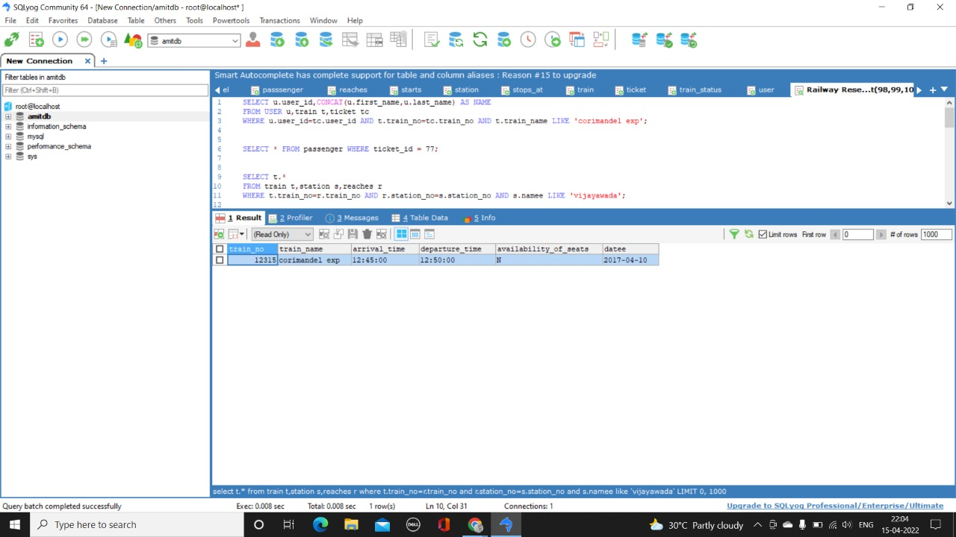

4. Display time at which train no 12315 reaches station no 111?

SELECT r.*,s.namee

FROM reaches r,station s WHERE r.station_no=s.station_no;

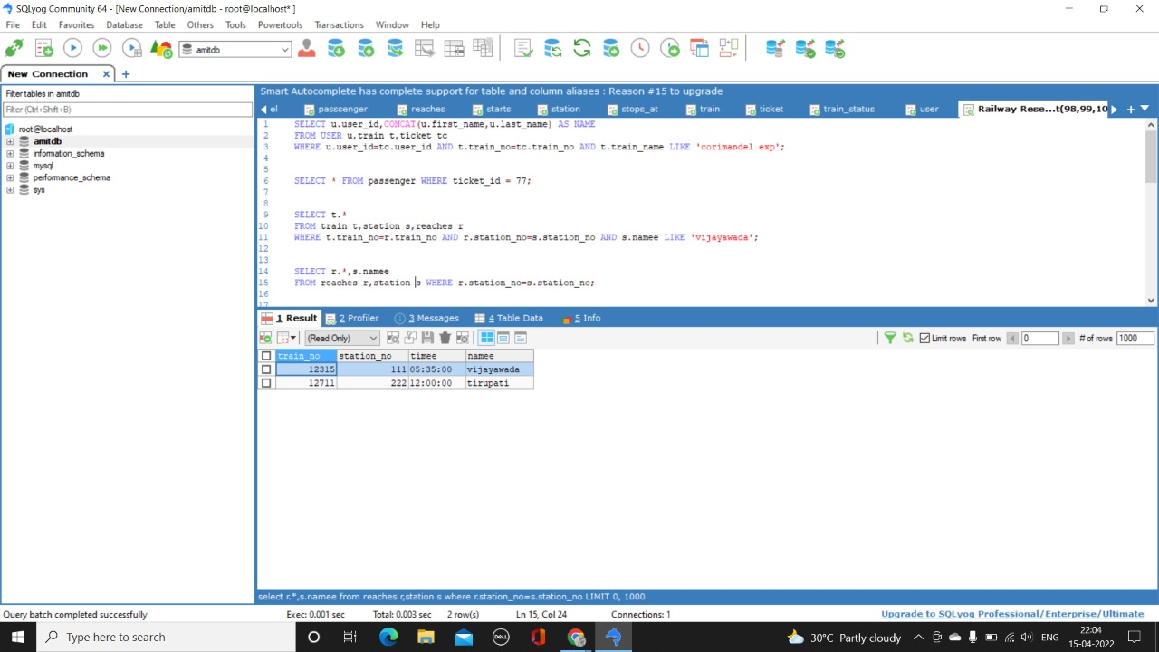

5. Display details of all those users who cancled tickets for train no 12315?

SELECT u.* FROM USER u,ticket t,cancel c

WHERE c.user_id=u.user_id AND c.id=t.id AND t.train_no LIKE 12315;

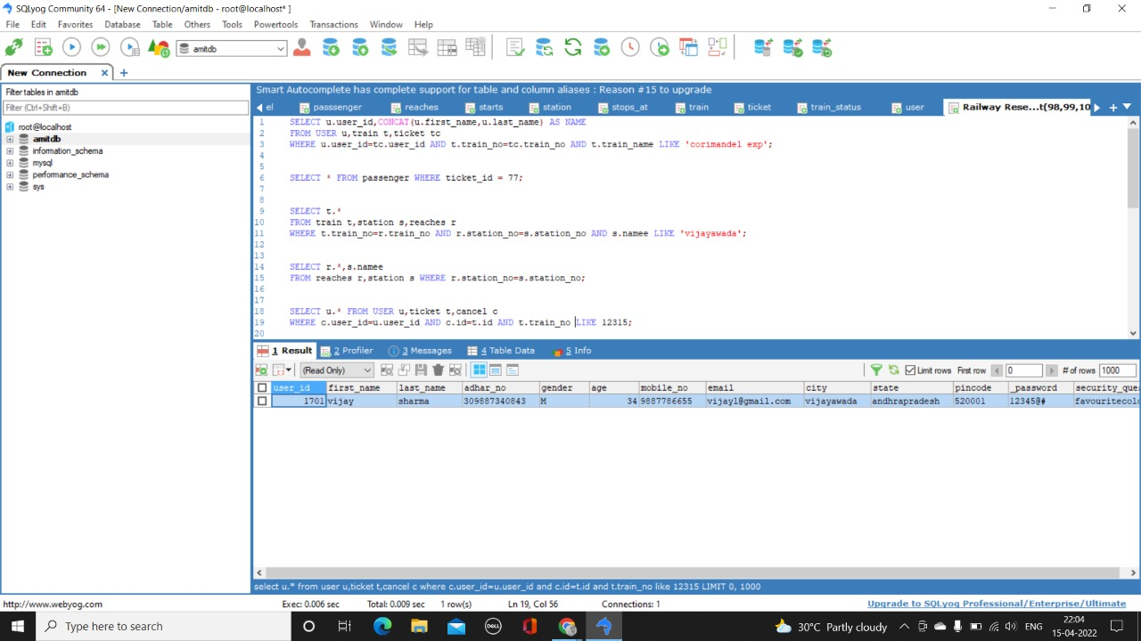

6. Diplay the train no with increasing order of the fares of class 1?

SELECT

ts.train_no,ts.fare1,t.train_name

FROM train_status ts,train t WHERE t.train_no=ts.train_no ORDER BY fare1 ASC;

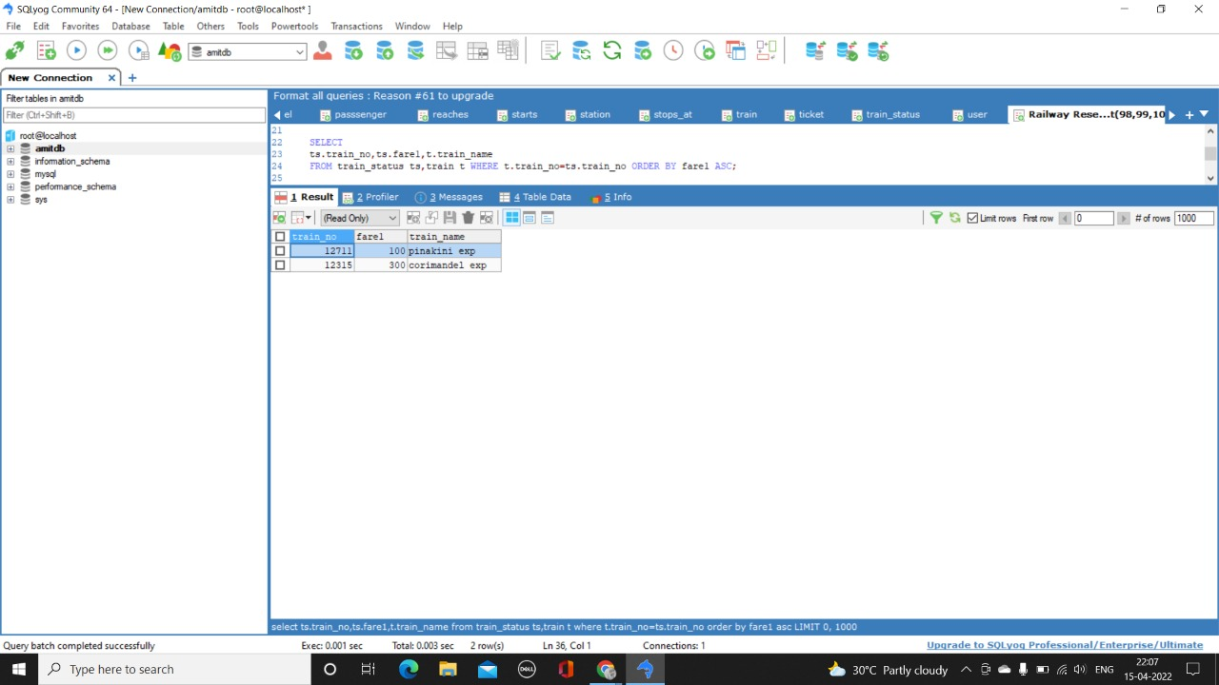

7. Diplay the train no with decreasing order of the fares of class 1?

SELECT

ts.train_no,ts.fare1,t.train_name

FROM train_status ts,train t WHERE t.train_no=ts.train_no ORDER BY fare1 DESC;

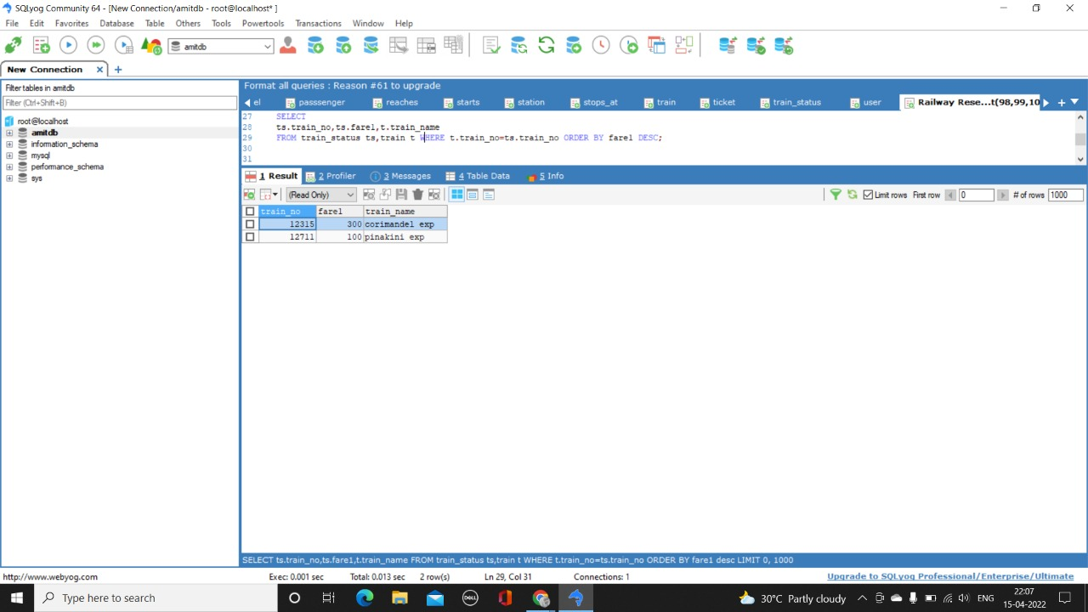

8. Display passenger details for train corimandel?

SELECT p.*

FROM passenger p,train t,ticket tc

WHERE tc.train_no=t.train_no AND tc.id=p.ticket_id AND t.train_name LIKE 'corimandel exp';

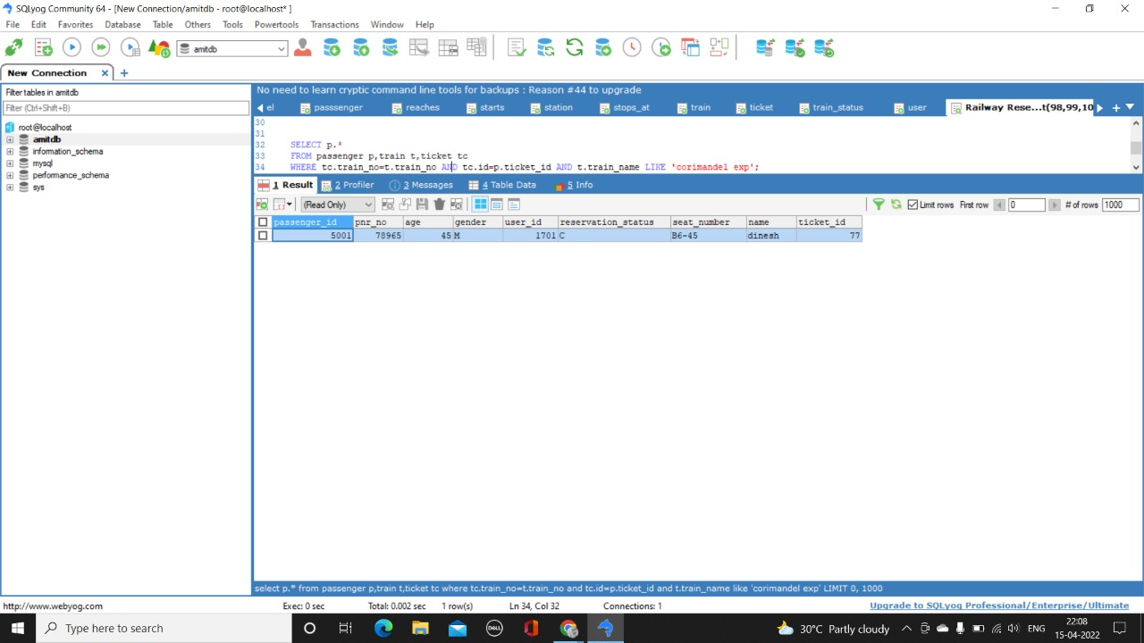

9. Display immediate train from tirupati to Vijayawada?

SELECT DISTINCT t.*

FROM train t,station s,STARTS st,stops_at sa

WHERE st.station_no=(SELECT station_no FROM station WHERE namee LIKE 'tirupati')

AND sa.station_no=(SELECT station_no FROM station WHERE namee LIKE 'vijayawada') ORDER BY datee;

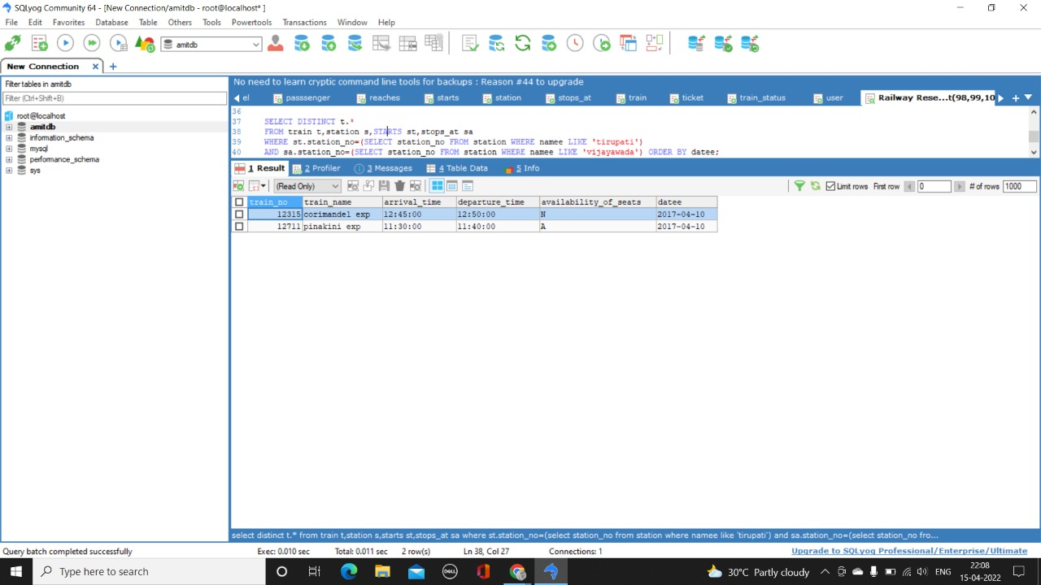

10. Display the train no which haults for more time in station no 111?

SELECT train_no FROM station HAVING MAX(hault);

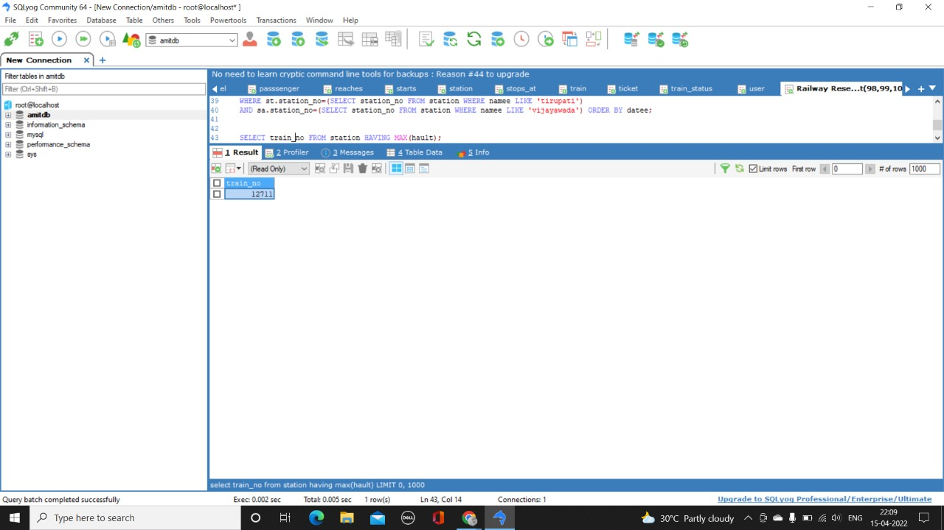

11. Display details of all those passengers whose status is confirmed for train no 12315?

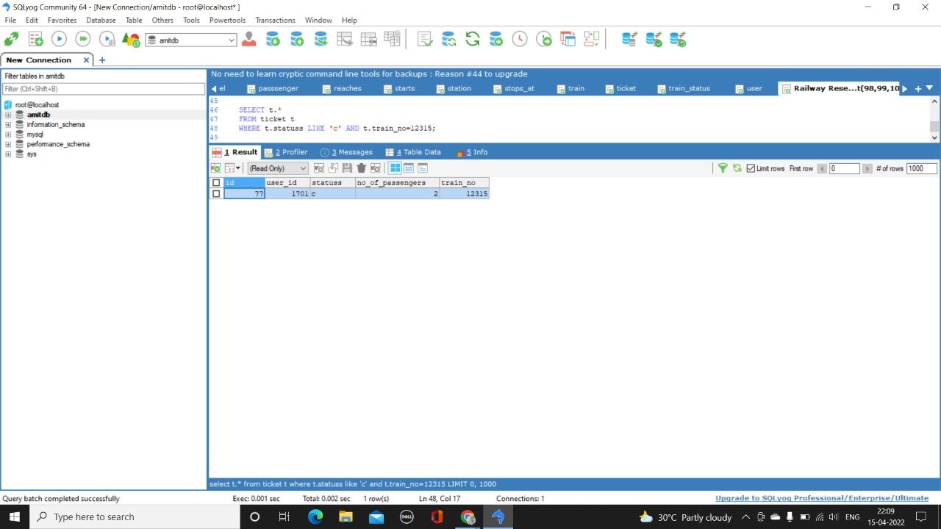

**Conclusion and Future Work:-**

In our project Railway reservation system we have stored all the information about the Trains scheduled and the users booking tickets and even status of trains, seats etc. This data base is helpful for the applications which facilitate passengers to book the train tickets and check the details of trains and their status from their place itself it avoids inconviniences of going to railway station for each and every query they get. We had considered the most important requriments only, many more features and details can be added to our project inorder to obtain even more user friendly applications. These applications are already in progress and in future they can be upgraded and may become part of amazing technology.

**References:-**

https://www.slideshare.net/shashankkarnati/railway-management-system-database-mini-project#:~:text=The%20Railway%20Reservation%20System%20facilitates,of%20the%20booked%20ticket%2C%20etc